**Step 1: Create React App**

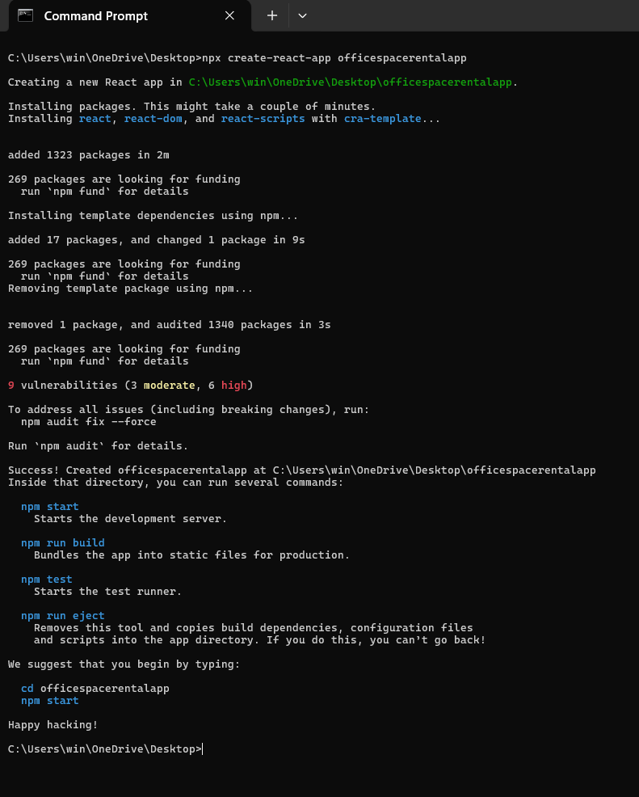

**Step 2: Clean the Boilerplate**

Inside src, delete unnecessary files like:

App.test.js, logo.svg, reportWebVitals.js, setupTests.js

Update App.js to your custom component.

**Step 3: Start Coding**

Edit src/App.js as follows:

import React from "react";

// JSX heading element

const heading = <h1>Office Space Rental App</h1>;

// Office image element

const officeImage = "https://imgs.search.brave.com/qEn2pJW9YcD00IwGX7qVmg82HWuP5gvWJdWewFBXIV0/rs:fit:860:0:0:0/g:ce/aHR0cHM6Ly90My5m/dGNkbi5uZXQvanBn/LzAzLzk2LzMwLzg0/LzM2MF9GXzM5NjMw/ODQxN19paFFCZVpU/WGkyTnFrSzZrR0Vs/WHNldUZkNmZBbjVX/TC5qcGc"; // use any image URL

const imageElement = <img src={officeImage} alt="Office" height="200" width="300" />;

// Office object

const office = {

  name: "Ocean View Workspaces",

  rent: 55000,

  address: "Bandra Kurla Complex, Mumbai"

};

// Office list

const officeList = [

  { name: "Ocean View", rent: 55000, address: "Bandra, Mumbai" },

  { name: "Tech Park", rent: 65000, address: "Whitefield, Bangalore" },

  { name: "Skyline Tower", rent: 60000, address: "CyberCity, Gurgaon" }

];

// Component rendering

function App() {

  return (

    <div style={{ padding: "20px", fontFamily: "Arial" }}>

      {heading}

      {imageElement}

      <h2>Featured Office</h2>

      <p><strong>Name:</strong> {office.name}</p>

      <p><strong>Rent:</strong> <span style={{ color: office.rent < 60000 ? "red" : "green" }}>{office.rent}</span></p>

      <p><strong>Address:</strong> {office.address}</p>

      <h2>All Available Offices</h2>

      {officeList.map((item, index) => (

        <div key={index} style={{ marginBottom: "10px" }}>

          <p><strong>Name:</strong> {item.name}</p>

          <p>

            <strong>Rent:</strong>{" "}

            <span style={{ color: item.rent < 60000 ? "red" : "green" }}>{item.rent}</span>

          </p>

          <p><strong>Address:</strong> {item.address}</p>

          <hr />

        </div>

      ))}

    </div>

  );

}

export default App;

**Step4: Run the Project**

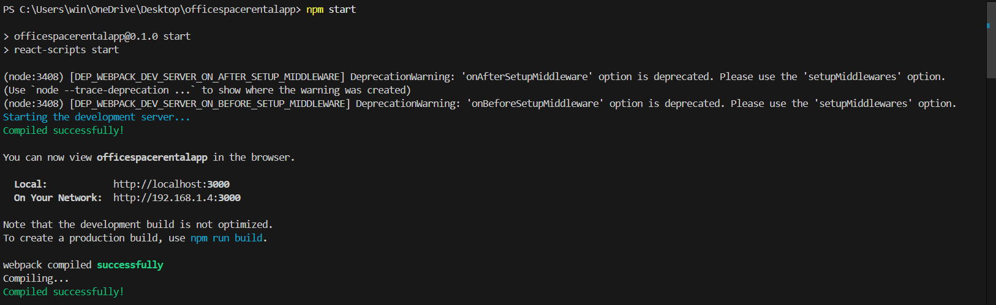

**Output:**  
